Your Paper's Title Starts Here: Please Center
use Helvetica (Arial) 14
FULL First Author^{1, a}, FULL Second Author^{2,b} and Last Author^{3,c}
¹Full address of first author, including country
²Full address of second author, including country
³List all distinct addresses in the same way
ªE-mail, ^{b}E-mail, ^{c}E-mail
Abstract
Please use Times New Roman 12 with 1.25 line spacing. Please make the page settings of your word processor to A4 format (21 x 29,7 cm or 8 x 11 inches); with the margins: bottom 1.5 cm (0.59 in) and top 2.5 cm (0.98 in), right/left margins must be 2 cm (0.78 in). Deadline is 30 May 2017. All papers must be written in English.
 | 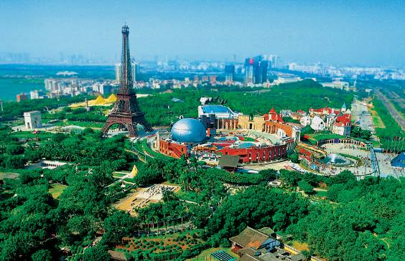
Fig.1 –Caption 1(Times New Roman 11) | Fig.2–Caption 2(Times New Roman 11)
References
[1] J. van der Geer, J.A.J. Hanraads, R.A. Lupton, The art of writing a scientific article, J. Sci. Commun. 163 (2000) 51-59.
Reference to a book:
[2] W. Strunk Jr., E.B. White, The Elements of Style, third ed., Macmillan, New York, 1979.
Reference to a chapter in an edited book:
[3] G.R. Mettam, L.B. Adams, How to prepare an electronic version of your article, in: B.S. Jones, R.Z. Smith (Eds.), Introduction to the Electronic Age, E-Publishing Inc., New York, 1999, pp. 281-304.
[4] R.J. Ong, J.T. Dawley and P.G. Clem: submitted to Mechanical Engineering (2003)
[5] P.G. Clem, M. Rodriguez, J.A. Voigt and C.S. Ashley, U.S. Patent 6,231,666. (2001)
[6] Information on http://www.imcc1983.org/

